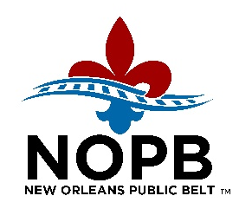

2026 Board Meetings

Month | Regular Board  (1:30 p.m.*)
January | Thursday, 22nd
February | Thursday, 26th
March | Thursday, 26th
April | Thursday, 23rd
May | Thursday, 21st
June | Thursday, 25th
July | Thursday, 23rd
August | Thursday, 27th
September | Thursday, 24th
October | Thursday, 22nd
November | Thursday, 19th
December | Thursday, 17th

*Meeting dates/times are subject to change.

Current and past meeting agendas and minutes can be found on the NOPB’s website.

